Digital Lock - Code Changing Instructions
Remove the keypads from the main gate lock body. The fixing screws are located at the top and bottom on the inside keypad these are removed by using the hexagonal key provided.
Remove the 2 or 4 red coloured retaining screws from the back of the keypads. Take extra care to keep the keypad on a flat surface when removing the cover plate as this has a number of springs attached.
You will now see that there are 5 red coloured coded tumblers and 8 blue coloured uncoded tumblers plus 1 clear tumbler (C button)
To change your code push the C button and hold it. You can then easily remove one or more of your coded and un-coded tumblers using the tweezers supplied.
Please note you should never remove the C tumbler or take your finger off of the C button when changing the code.
Please note the different shapes of the tumblers before reinserting them into the lock body. Firstly there is a difference in shape between the coded and un-coded tumblers as illustrated below. Secondly when refitting into the lock body they must be fitted facing the correct ways again see the illustration below. All square cut-outs must face outwards. Once inserted correctly the dimple on the tumbler will sit in the cut-out on the coding chamber.
After you have refitted the tumblers and have made a note of the new code please replace the metal plate with the 2 or 4 red screws.
Please note-with the spare tumblers provided you can either increase the number of digits in your code to 6-7 or reduce to 3-4.
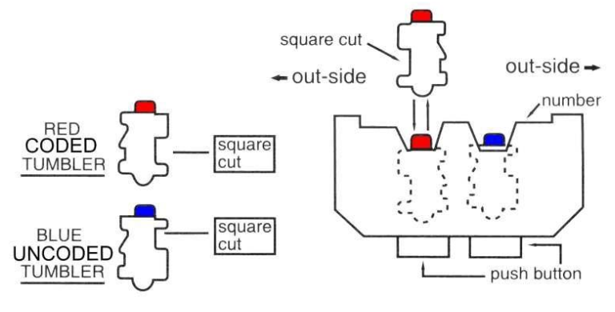

Please call our helpline for spares, repairs and technical advice – 01708 225700

